Sanborn Regional Middle School
Tuesday, December 3, 2019 ~ Today is a
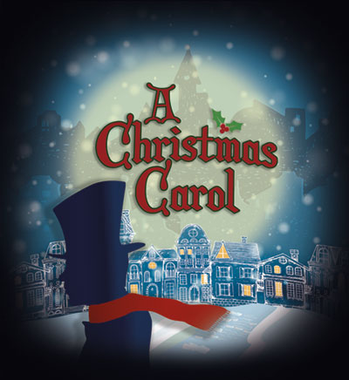

Sanborn Community Presents:
the seasonal favorite A Christmas Carol

SRHS Auditorium

Friday December 6, 7:00 PM
Saturday Matinee, December 7, 2:00 PM

*Snow date: Sunday, December 8, 2:00 PM

- AFTER-SCHOOL ACTIVITIES

DATE | December 3  Tuesday | December 4  Wednesday | December 5  Thursday | December 6  Friday | December 9  Monday
Clubs and Activities | 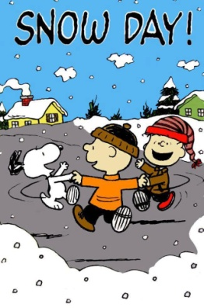 | Play Rehearsal  5:00-7:30  SRHS | Play Rehearsal  5:00-7:30  SRHS | A Christmas Carol  7:00 PM  SRHS Auditorium | Student Council  2:30-3:30
Basketball |  | BOYS A  3:00-4:30 SWASEY  Bus 201  BOYS B  5:00-6:30 SRMS  GIRLS A  4:30-6:00 SWASEY  GIRLS B  2:30-4:00 SRMS | BOYS A  4:00-5:30 SRMS  BOYS B  HOME  3:30  GIRLS A  2:30-4:00 SRMS  GIRLS B  HOME  5:00 | BOYS A  AWAY  3:30  BOYS B  5:00-6:30 SRMS  GIRLS A  AWAY  5:00  GIRLS B  2:30-4:00 SRMS | BOYS A  HOME  3:30  BOYS B  AWAY  5:00  GIRLS A  HOME  3:30  GIRLS B  AWAY  3:30

- DATES TO KEEP IN MIND

- Friday, December 6 – School Play, A Christmas Carol – 7:00 PM, SRHS Auditorium
- Saturday, December 7 – School Play, A Christmas Carol – 2:00 PM Matinee, SRHS Auditorium
- Friday, December 13 – School Dance, All grades, SRMS Gym, 7:00 PM – 9:00 PM

